Project Design Phase
Solution Architecture
Date | 08 October 2026
Team ID | [TEAM ID]
Project Name | Auto Ticket Classification Using ServiceNow Flow Designer
Maximum Marks | 4 Marks

Solution Architecture:
Solution architecture bridges the gap between the business problem and the technology solution. For this project, the goals are:
Find a suitable ServiceNow solution for the manual ticket classification problem of the school IT helpdesk.
Describe the structure, characteristics and behaviour of the solution to project stakeholders.
Define the features, development phases and solution requirements.
Provide specifications according to which the solution is defined, managed and delivered.
Solution Architecture Diagram:
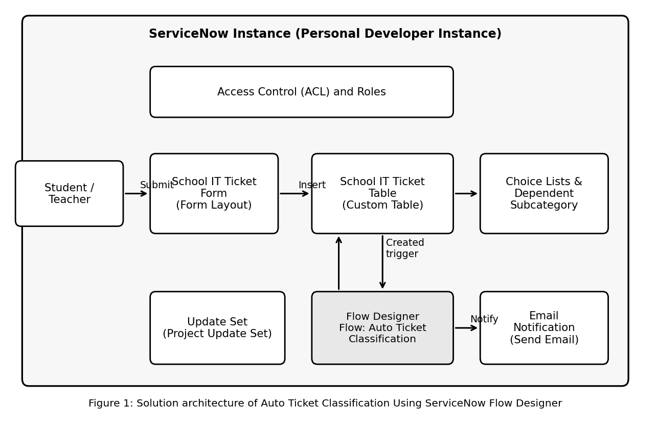
Description of the architecture:
School IT Ticket form and table: the caller submits the Caller and Short Description through the form; the record is stored in the custom School IT Ticket table with an auto-generated Number.
Choice lists and dependent fields: Category, Subcategory and State are choice fields; Subcategory options depend on the selected Category.
Flow Designer flow: the trigger fires when a record is created in the School IT Ticket table. The flow evaluates the text with conditions and uses the Update Record action to set Category and Subcategory, then uses the Send Email action to notify the caller.
Access control and update set: access control rules restrict who can view or modify tickets, and the Project Update Set captures all configuration.
Reference: https://docs.servicenow.com

